## Example 6

The first step is to read in the data.

dat<-read.csv("example6.csv")

The next step is to check out the structure

str(dat)

## 'data.frame': 240 obs. of 5 variables:  
## $ percent : num 78.2 72.7 68 89.9 92.5 ...  
## $ position : int 1 1 1 1 1 1 1 1 1 1 ...  
## $ distractor: Factor w/ 2 levels "no","yes": 2 2 2 2 2 2 2 2 2 2 ...  
## $ subject : int 1 2 3 4 5 6 7 8 9 10 ...  
## $ subject2 : int 1 2 3 4 5 6 7 8 9 10 ...

From the structure we can see that position, subject, and subject2 should all be factor variables. So let's fix that.

dat$position<-as.factor(dat$position)  
dat$subject<-as.factor(dat$subject)  
dat$subject2<-as.factor(dat$subject2)

First we need to get only the data from the conjunction searches.

temp<-dat[dat$distractor=="yes",]

Now we can run our ANOVA.

summary(aov(percent~position, data=temp))

## Df Sum Sq Mean Sq F value Pr(>F)   
## position 9 10595 1177.2 16.27 <2e-16 ***  
## Residuals 110 7958 72.3   
## ---  
## Signif. codes: 0 '***' 0.001 '**' 0.01 '*' 0.05 '.' 0.1 ' ' 1

There's a significant effect of which position a word appears in on a list, F(9,110) = 16.3, p < .05. To interpret these data better, I'll create a line graph that shows the percent recalled for the various list positions when participants are distracted.

library(ggplot2)  
library(gplots)

##   
## Attaching package: 'gplots'

## The following object is masked from 'package:stats':  
##   
## lowess

library(dplyr)

##   
## Attaching package: 'dplyr'

## The following objects are masked from 'package:stats':  
##   
## filter, lag

## The following objects are masked from 'package:base':  
##   
## intersect, setdiff, setequal, union

temp<-temp%>%group_by(position)%>%  
 summarize(means=mean(percent),  
 sems=sd(percent)/sqrt(length(percent)))  
  
f<-ggplot(temp, aes(x=as.factor(position),  
 y=means,  
 group=1))+  
 geom_line(size=1)+  
 geom_point(size=2)+  
 geom_errorbar(aes(ymax=means+sems,  
 ymin=means-sems),  
 width=.2)+  
 ggtitle("Serial Position Effect")+  
 labs(x="List Position",y="Percent Recalled")+  
 theme(plot.title=element_text(size=15,face="bold",vjust=.5))+  
 theme(axis.title.x=element_text(size=12,face="bold",vjust=-.25))+  
 theme(axis.title.y=element_text(size=12,face="bold",vjust=1))+  
 theme(axis.text.x=element_text(size=10,face="bold",color="black"))+  
 theme(axis.text.y=element_text(size=10,face="bold",color="black"))+  
 coord_cartesian(ylim=c(min(temp$means)-2*max(temp$sems),  
 max(temp$means)+2*max(temp$sems)))+  
 theme(panel.border=element_blank(),axis.line=element_line())+  
 theme(panel.grid.major.x=element_blank())+  
 theme(panel.grid.major.y=element_line(color="darkgrey"))+  
 theme(panel.grid.minor.y=element_blank())  
f

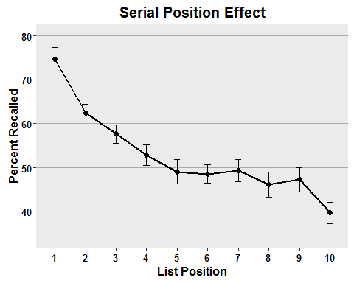 From the figure we can see that participants do the best on the words that occur at the beginning of the list and worst on the words that occur at the ending of the list.

Because I changed temp, I don't have the same data I analyzed last time, so I'm going to reuse the code I first used to create temp so I can perform the appropriate analysis.

temp<-dat[dat$distractor=="yes",]

Now I'll perform the within-subjects analysis.

summary(aov(percent~position+  
 Error(subject/position),data=temp))

##   
## Error: subject  
## Df Sum Sq Mean Sq F value Pr(>F)  
## Residuals 11 5671 515.6   
##   
## Error: subject:position  
## Df Sum Sq Mean Sq F value Pr(>F)   
## position 9 10595 1177.2 50.97 <2e-16 ***  
## Residuals 99 2286 23.1   
## ---  
## Signif. codes: 0 '***' 0.001 '**' 0.01 '*' 0.05 '.' 0.1 ' ' 1

Participants performed better on earlier list positions than they did on later list positions, F(9,99) = 51.0, p = .05.

Now, I'll perform a between-subjects 2-way ANOVA looking for effects of and interactions between list position and whether or not participants completed an intervening task.

summary(aov(percent~position*distractor, data=dat))

## Df Sum Sq Mean Sq F value Pr(>F)   
## position 9 14416 1601.8 22.70 < 2e-16 ***  
## distractor 1 2206 2205.6 31.26 6.65e-08 ***  
## position:distractor 9 5124 569.4 8.07 2.55e-10 ***  
## Residuals 220 15522 70.6   
## ---  
## Signif. codes: 0 '***' 0.001 '**' 0.01 '*' 0.05 '.' 0.1 ' ' 1

The analyses show that there was an effect of position, F(9,220) = 22.7, p < .05. There was also an effect of distractor, F(1,220) = 31.3, p < .05. There was also an interaction between position and distractor, F(9,220) = 8.07, p < .05.

To help me interpret the earlier analyses, I'll create line and grouped bar graphs for the data I analyzed. But first I need to summarize the data.

temp<-dat%>%group_by(position,distractor)%>%  
 summarize(means=mean(percent),  
 sems=sd(percent)/sqrt(length(n)))

Now I can create the figures.

f<-ggplot(temp, aes(x=position,  
 y=means,  
 group=distractor,  
 color=distractor))+  
 geom_line(size=1)+  
 geom_point(size=2)+  
 scale_color_manual(values=c("darkgreen","red"),  
 name="Distractor",  
 breaks=c("no","yes"),  
 labels=c("No", "Yes"))+  
 geom_errorbar(aes(ymax=means+sems, ymin=means-sems),width=.2)+  
 ggtitle("Serial Position With and Without Distraction")+  
 labs(x="List Position",y="Percent Recalled")+  
 theme(plot.title=element_text(size=15,face="bold",vjust=.5))+  
 theme(axis.title.x=element_text(size=12,face="bold",vjust=-.25))+  
 theme(axis.title.y=element_text(size=12,face="bold",vjust=1))+  
 theme(axis.text.x=element_text(size=10,face="bold",color="black"))+  
 theme(axis.text.y=element_text(size=10,face="bold",color="black"))+  
 coord_cartesian(ylim=c(min(temp$means)-2*max(temp$sems),  
 max(temp$means)+2*max(temp$sems)))+  
 theme(panel.border=element_blank(),axis.line=element_line())+  
 theme(panel.grid.major.x=element_blank())+  
 theme(panel.grid.major.y=element_line(color="darkgrey"))+  
 theme(panel.grid.minor.y=element_blank())+  
 theme(legend.position=c(.4,.76))+  
 theme(legend.background=element_blank())+  
 theme(legend.background=element_rect(color="black"))+  
 theme(legend.title=element_blank())+  
 theme(legend.title=element_text(size=12))+  
 theme(legend.title.align=.5)+  
 theme(legend.text=element_text(size=10,face="bold"))  
f

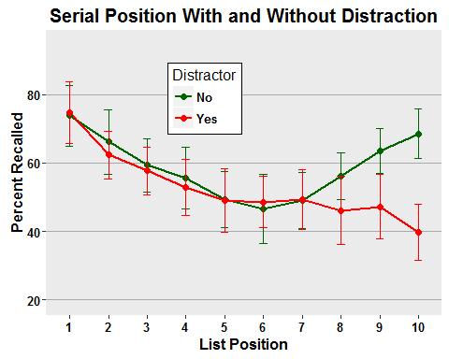

f<-ggplot(temp, aes(x=position,  
 y=means,  
 fill=distractor))+  
 geom_bar(stat="identity",position=position_dodge())+  
 scale_fill_manual(values=c("darkgreen","red"),  
 name="Distractor",  
 breaks=c("no","yes"),  
 labels=c("No", "Yes"))+  
 geom_errorbar(aes(ymax=means+sems,  
 ymin=means-sems),  
 width=.2,  
 position=position_dodge(.9))+  
 ggtitle("Serial Position With and Without Distraction")+  
 labs(x="List Position",y="Percent Recalled")+  
 theme(plot.title=element_text(size=15,face="bold",vjust=.5))+  
 theme(axis.title.x=element_text(size=12,face="bold",vjust=-.25))+  
 theme(axis.title.y=element_text(size=12,face="bold",vjust=1))+  
 theme(axis.text.x=element_text(size=10,face="bold",color="black"))+  
 theme(axis.text.y=element_text(size=10,face="bold",color="black"))+  
 coord_cartesian(ylim=c(min(temp$means)-2*max(temp$sems),  
 max(temp$means)+2*max(temp$sems)))+  
 theme(panel.border=element_blank(),axis.line=element_line())+  
 theme(panel.grid.major.x=element_blank())+  
 theme(panel.grid.major.y=element_line(color="darkgrey"))+  
 theme(panel.grid.minor.y=element_blank())+  
 theme(legend.position=c(.4,.76))+  
 theme(legend.background=element_blank())+  
 theme(legend.background=element_rect(color="black"))+  
 theme(legend.title=element_blank())+  
 theme(legend.title=element_text(size=12))+  
 theme(legend.title.align=.5)+  
 theme(legend.text=element_text(size=10,face="bold"))  
f

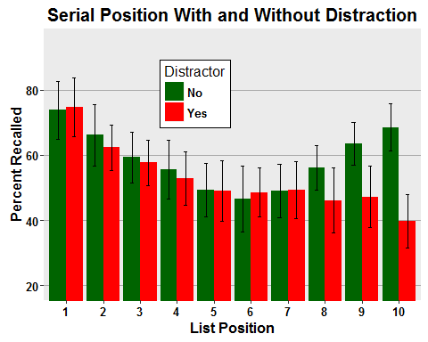

From the figures and earlier analyses we can see that people generally perform best for the beginning and ending words in a list. We can also see that in general participants performed worse when they had an intervening distracting task. Most importantly, the interaction reveals that although individuals without intervening distracting tasks perform best on the earliest and latest list positions, those with the distractor tasks performed better on earlier positions than on later ones.

Here I'm performing a within-subjects two-way ANOVA to examine for the effects of and interactions between list position and distraction.

summary(aov(percent~position*distractor+  
 Error(subject/(position*distractor)),  
 data=dat))

##   
## Error: subject  
## Df Sum Sq Mean Sq F value Pr(>F)  
## Residuals 11 10319 938.1   
##   
## Error: subject:position  
## Df Sum Sq Mean Sq F value Pr(>F)   
## position 9 14416 1601.8 71.34 <2e-16 ***  
## Residuals 99 2223 22.5   
## ---  
## Signif. codes: 0 '***' 0.001 '**' 0.01 '*' 0.05 '.' 0.1 ' ' 1  
##   
## Error: subject:distractor  
## Df Sum Sq Mean Sq F value Pr(>F)   
## distractor 1 2206 2205.6 128.4 2.09e-07 ***  
## Residuals 11 189 17.2   
## ---  
## Signif. codes: 0 '***' 0.001 '**' 0.01 '*' 0.05 '.' 0.1 ' ' 1  
##   
## Error: subject:position:distractor  
## Df Sum Sq Mean Sq F value Pr(>F)   
## position:distractor 9 5124 569.4 20.19 <2e-16 ***  
## Residuals 99 2792 28.2   
## ---  
## Signif. codes: 0 '***' 0.001 '**' 0.01 '*' 0.05 '.' 0.1 ' ' 1

From the analyses and the figures we can see that generally people perform best for the initial and later list positions, F(9,99) = 71.3, p < .05. We can also see that people are generally more accurate to recall words when they don't have an intervening distractor tasks to complete, F(1,11) = 128.4, p < .05. Finally, we can see that those without a distractor task perform best for the words at the beginning and end of the lists while, those with a distractor task perform best for the initial words and worst for the ending words, F(9,99) = 20.2, p < .05.

Finally, I'll conduct a mixed ANOVA in which position varies within participants and distraction varies between participants.

summary(aov(percent~position*distractor+  
 Error(subject2/position),  
 data=dat))

##   
## Error: subject2  
## Df Sum Sq Mean Sq F value Pr(>F)   
## distractor 1 2206 2205.6 4.618 0.0429 *  
## Residuals 22 10508 477.6   
## ---  
## Signif. codes: 0 '***' 0.001 '**' 0.01 '*' 0.05 '.' 0.1 ' ' 1  
##   
## Error: subject2:position  
## Df Sum Sq Mean Sq F value Pr(>F)   
## position 9 14416 1601.8 63.25 <2e-16 ***  
## position:distractor 9 5124 569.4 22.48 <2e-16 ***  
## Residuals 198 5014 25.3   
## ---  
## Signif. codes: 0 '***' 0.001 '**' 0.01 '*' 0.05 '.' 0.1 ' ' 1

From our anlyses, we can see that individuals without distracting tasks performed better than those who had, F(1,22) = 4.6, p = .0429. Additionally, participants generally performed better on the words at the beginning and ends of the lists, F(9,198) = 63.3, p < .05. Finally, we can see that distracted individuals performed best on the initial words only while individuals who weren't distracted performed well on items at the beginning and end of the lists, F(9,198) = 22.5, p < .05.